This week, the Math Department brings us…

**Serge Lang Undergraduate Lecture**

Thursday, September 22, 2016

60 Evans, 4pm



The annual Serge Lang Lecture will be held this coming Thursday! This year's talk, titled *The Mathematics of Doodling*, will be given by **Professor Ravi Vakil of** Stanford University. Join us at **3pm** **in** **1015 Evans** for **tea and pie** with the speaker. The talk starts after the tea at **4pm** **in** **60 Evans.** After the talk, come for the **Serge Lang Dinner** at **5:10pm back in 1015 Evans,**which will be attended by the speaker as well as students and professors. The tea, pie, and talk will all be **free**; tickets to the dinner can be purchased for $12 at 938 Evans or $15 at the door.

**BmMT Problem Writing Session**

**Math Monday Series**

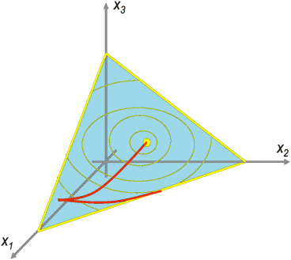

The Berkeley mini Math Tournament is a middle school math competition held on campus, written, directed and put on by UC Berkeley students. Come to BmMT’s Problem Writing Session on **Wednesday, September 21 at 6pm in 740 Evans** to learn how to write the math problems used in the competition. We will be setting up a problem submission system with git, so bring your laptop! Dinner will be provided.